## horizontal line



Game Collector

10.20.2021

**─**

Designer: Alex Wacker

# 

# The Problem

The video game community is known for its vast breadth of technology of imagination when it comes to the interactive medium. Many players emasse hundreds of plastic boxes and discs in their home, and it can become daunting sifting through them sorting them in any meaningful way.

The *Game Collector* project will enable its users to enter an infinite number of games into its database (through a thoughtful UI) and provide all sorts of metadata and ranking information.

## Users

The primary users for this project will be video game “players” and video game “collectors.” A collector is many times a player, but not vice versa.

## Value

Users will be given the ability to enter any video game with a title, publisher, developer, genre, purchase price, and description into the web application. This will store it in the database and associate directly to their user profile.

## User Interface

The UI will primarily be an HTML page that interacts with a service layer/database to display, edit, delete entries in a collection, as well has house profile info to associate to the collection

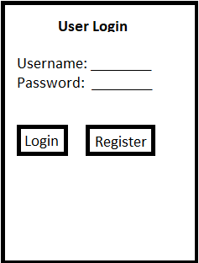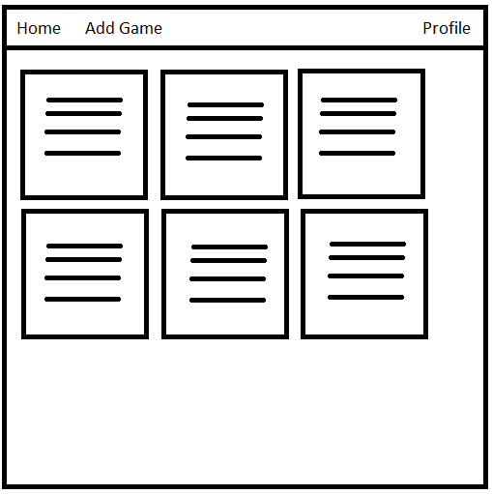

# Minimum Viable Product

The *Game Collector* application’s MVP will be a Node.js based web application that interacts with a MySQL backend to store the user’s game entries.

## Capabilities

The user’s will be able to do the following:

* Create a new video game entry with various metadata
  + Title
  + Genre
  + Publisher
  + Developer
  + Purchase Price
  + Description
  + 1-5 Star Rating
* Update existing records when information changes
* Delete individual records when desired
* Create personal profiles to associate DB entries to

## Architecture

The application will be an HTML front end which will interact with a service layer created with Ionic / Node to interface with a MySQL database, all hosted on Heroku for public access.

I expect the data being house to be structured in 2 tables:

* “Game” table -- holds all metadata pertaining to a game entry (as listed above), as well as an AssocID that ties back to a profile.
* “Profile” table -- holds all created profiles with a unique ID and name.